SQL Mini-Project

“My Wardrobe”

Daniel Colantonio

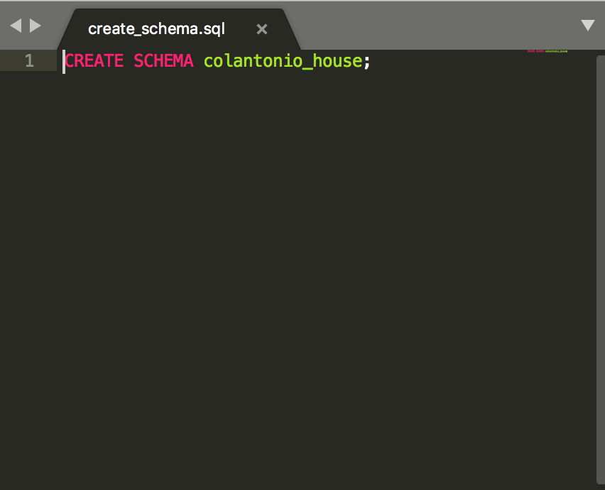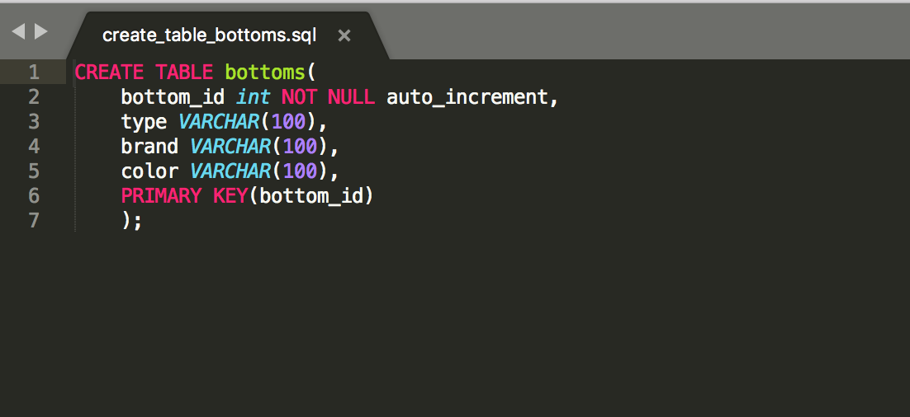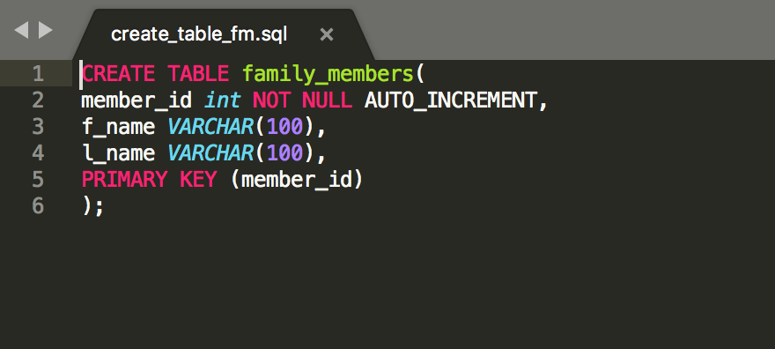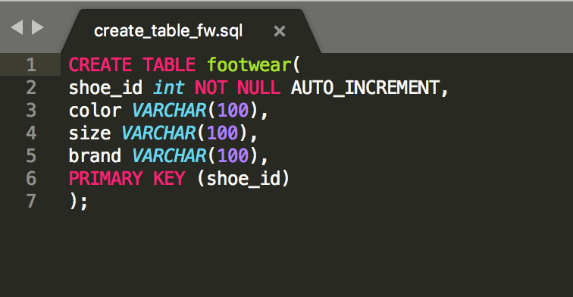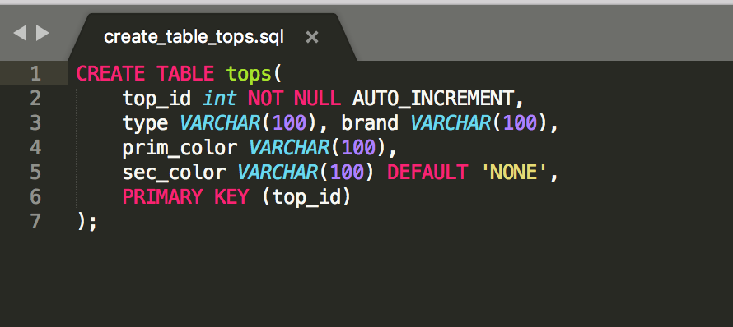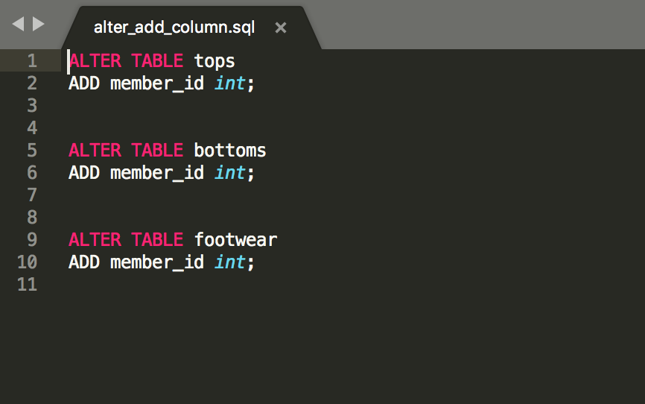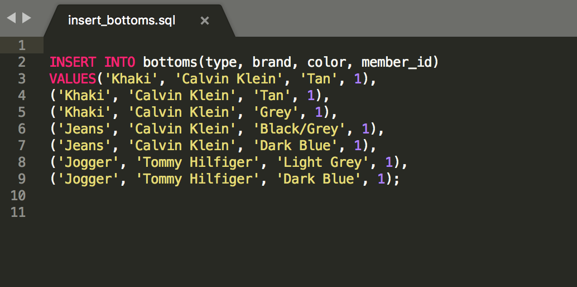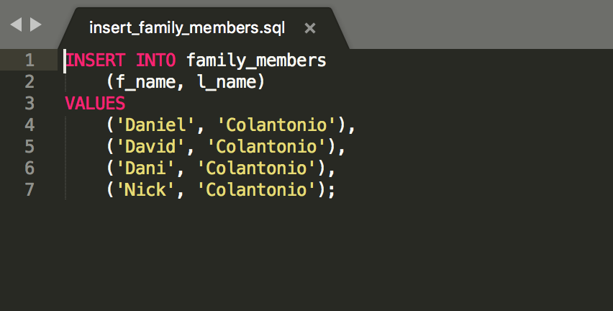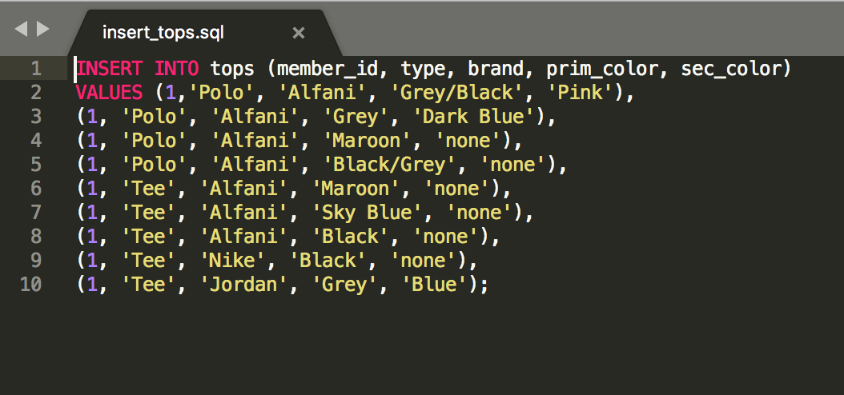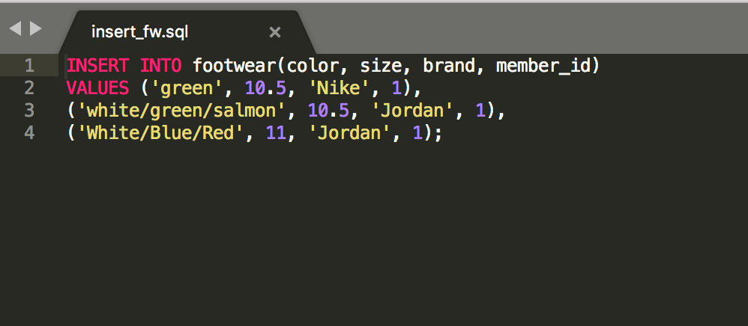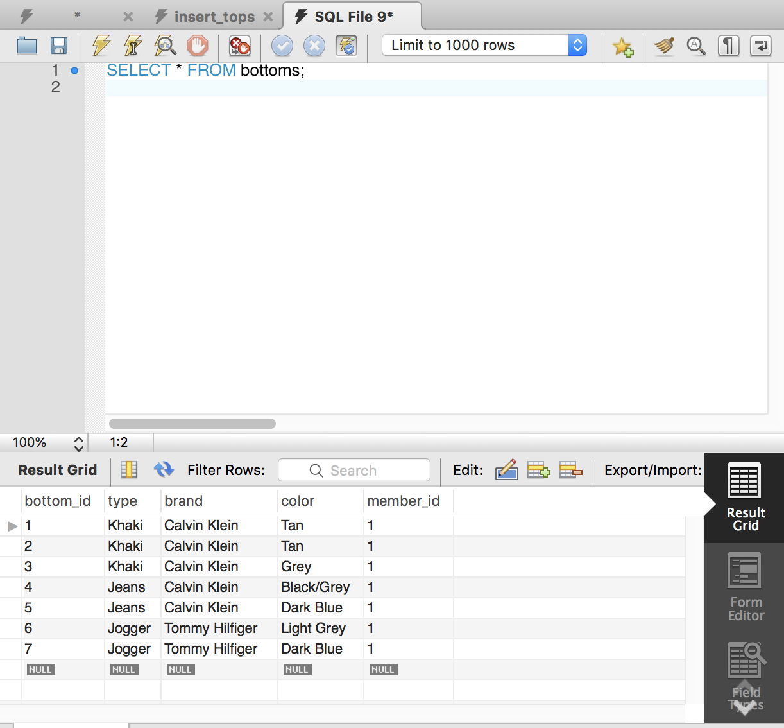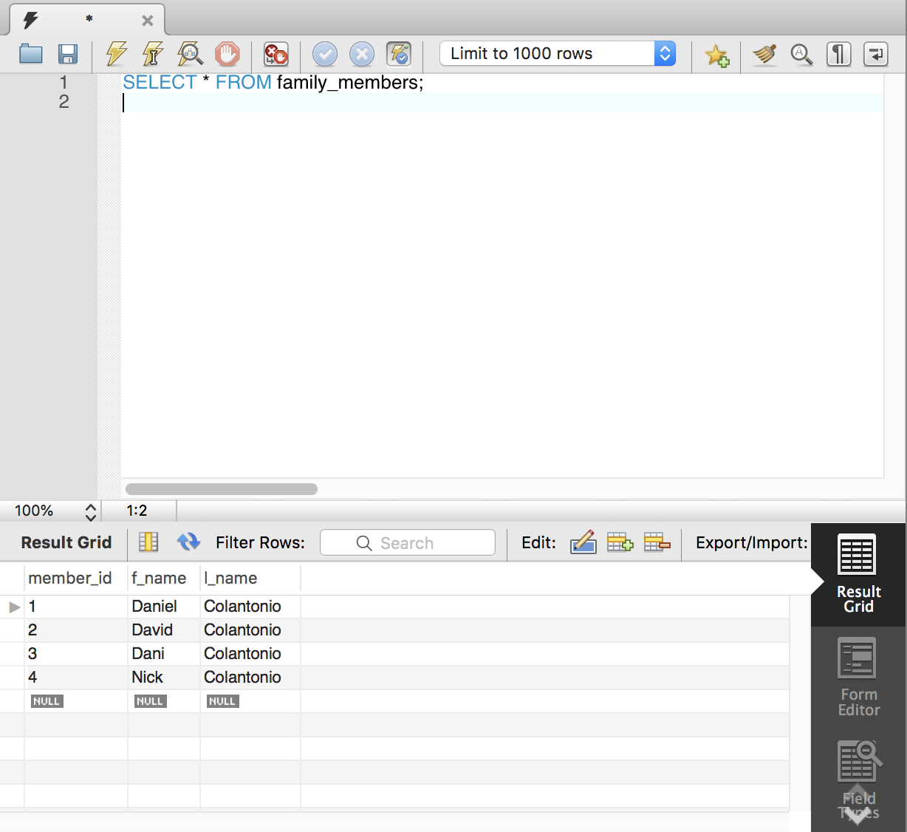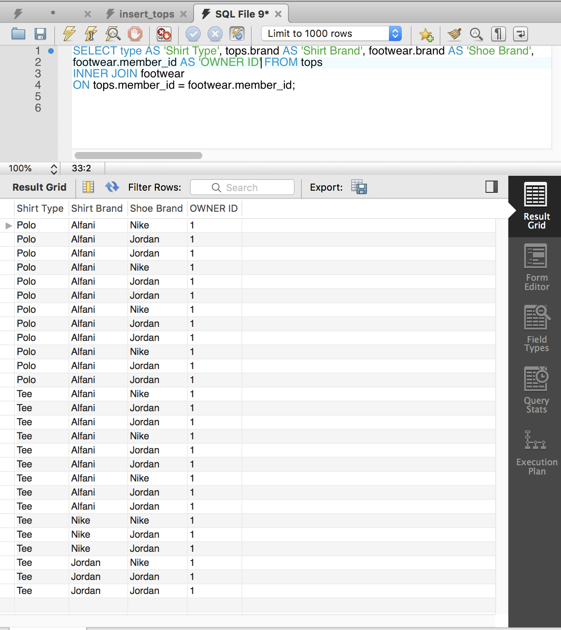

1. I created a database for my household.

2.) I created a table for all bottoms (pants, shorts, etc…)

3.) I created a table for all family members who have clothes.

4.) I then created a table for all shoes

5.) Lastly, I created a table for all shirts and tops.

6.) I wanted a way to connect the tables through joins, to see which member of the family had what articles of clothing. I did this by adding the member_id to all of the tables.

7.) I inserted all of my pants into the bottoms database.

8.) I inserted all of my family members into the family_members database.

9.) I inserted all of my tops into the tops database with my member_id, the type of shirt, the brand, and primary and secondary colors of the shirt. Later, I will add size and material.

10.) I inserted all of shoes into the footwear table. As you can see, I do not have many right now. I plan to add columns “size” and “model” later.

11.) In order to show you that the previous queries worked, I have selected everything from the bottoms table and the family_members database below.

12.) To wrap it up, I ran an inner join using member_id from the footwear and shirts tables. It does not make much sense, but it is to show that I can connect two tables.

I only added my clothes to the database because I didn’t feel like going through my family’s closets. I hope you enjoyed my mini-project!